Game Overview:

Wish Me Luck – Video Slot

Tag Line:

As luck would have it, fortune isn’t far away!

There’s only one thing you need to play - WISH ME LUCK!
Test your luck and trigger all 3 different Bonuses!

Find the Pot of Gold and win up to 500x in the spectacular Pot of Gold Bonus! Help the Leprechaun chase the end of the rainbow with the Rainbow Run bonus! Or make your dreams come true in the remarkable Wishing Well bonus!

Fortune favours the bold, so keep calm and shout WISH ME LUCK!
Theme:
Irish, Leprechaun, Gold, Rainbow, Luck

Outline:
Wish Me Luck is a great Irish themed slot game. With 5 reels and 3 different bonuses, the fun never stops with Wish Me Luck!
Notable Features:
- Pot Of Gold Bonus
- Rainbow Run Bonus
- Wishing Well Bonus
- 20 lines
- Colorful Animations

Symbol Profiles:

Sym# | Sym Name | Sym Image | Function
21 | Gold Pot Multiplier | 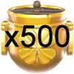 | Pays x500 of total bet
20 | Gold Pot Multiplier | 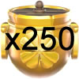 | Pays x250 of total bet
19 | Gold Pot Multiplier | 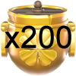 | Pays x200 of total bet
18 | Gold Pot Multiplier | 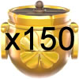 | Pays x150 of total bet
17 | Gold Pot Multiplier | 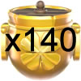 | Pays x140 of total bet
16 | Gold Pot Multiplier | 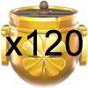 | Pays x120 of total bet
15 | Gold Pot Multiplier | 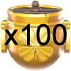 | Pays x100 of total bet
14 | Gold Pot Multiplier | 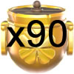 | Pays x90 of total bet
13 | Gold Pot Multiplier | 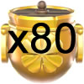 | Pays x80 of total bet
12 | Gold Pot Multiplier | 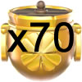 | Pays x70 of total bet
11 | Gold Pot Multiplier | 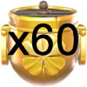 | Pays x60 of total bet
10 | Gold Pot Multiplier | 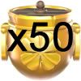 | Pays x50 of total bet
09 | 10
08 | J
07 | Q | 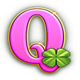
06 | K | 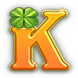
05 | A | 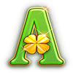
04 | LOGO | 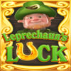
03 | WILD |  | WILD and substitutes for all symbols except WELL, RAINBOW and GOLD POT.
02 | WELL |  | 3 or more triggers Wishing Well bonus.
01 | RAINBOW |  | 3 or more triggers Rainbow Run bonus.
00 | GOLD POT |  | 3 or more triggers Free Spins bonus

General Rules:
Payouts are made according to the paytable. All wins are multiplied by the bet per line. Highest win paid per winning combination. Coinciding wins are added. Line wins are paid from left-to-right. Only positions containing the winning symbol are used in determining the win for that symbol.

