i

Money Drop Live
Updates

Confidential

Overview
Our newly released game show Money Drop has received several improvements:
- 2 Zones Win and Double boosters now apply on all Multiplier bets,
- Players can distribute their Money on all Drop Zones in the Quick Drop game,
- All Wins and all Ties grant multipliers in the Card Clash game,
- New side bet added for Watchers,
- Bet On All button added
Also, we are highlighting a detail about the Autoplay in the Money Drop game.

Changes to Boosters
Double and 2 Zones Win boosters can now apply on all Multiplier Bets. They are no longer limited to specific Drop Games.
Note that the 2 Zones Win is applied on all Drop Rounds that take place during a Drop Rounds game.
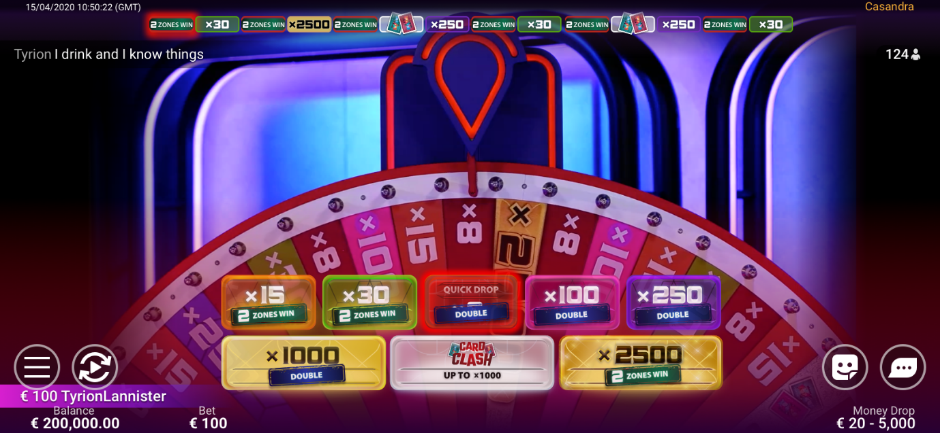

Quick Drop Game New Flow
When players enter the Quick Drop game, they get their Money in 4 Money Stacks, instead of just one. This is because now the flows of the Quick Drop game and the Drop Rounds game are more similar: players can distribute their Money on all 4 Drop Zones.
This means that also the Quick Drop game can be played safely: players can distribute their Money on all positions and get a granted win.
In addition, players can now use the Autostack and Autoplay features in the Quick Drop game
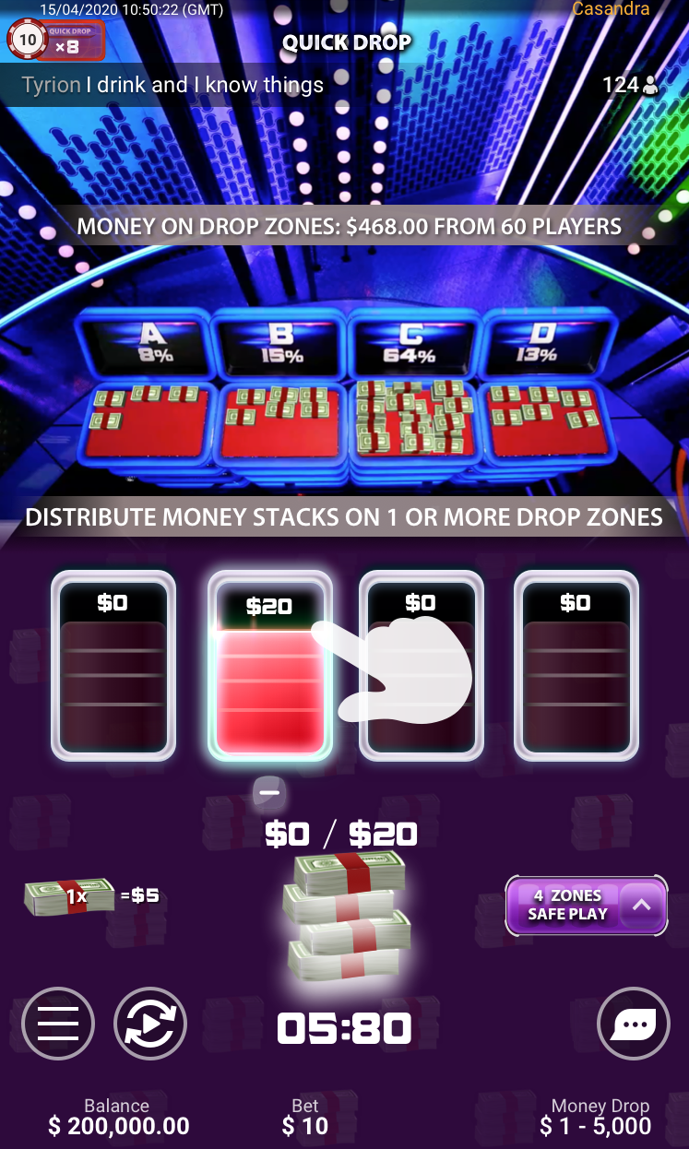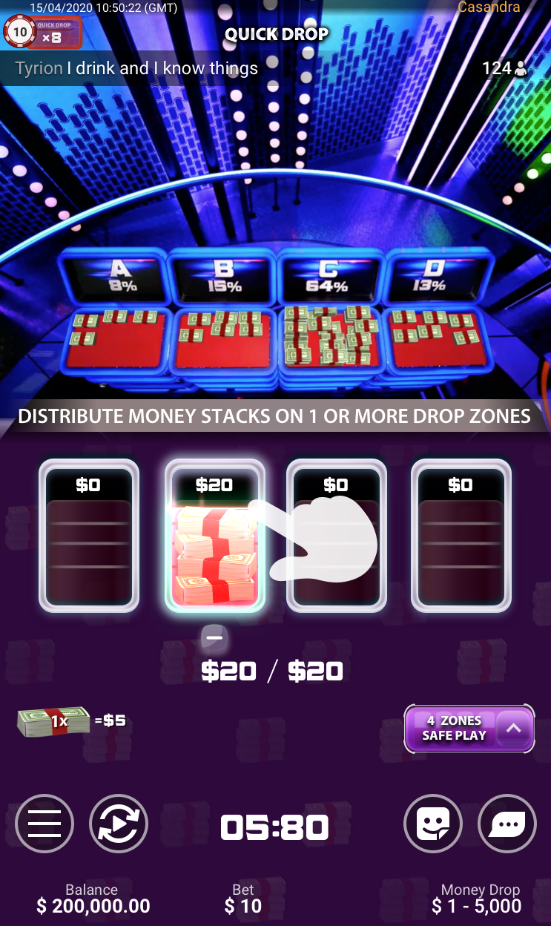

Improvements to Card Clash Game
The biggest change is related to how the multipliers are granted, as now any Win and any Tie will grant a multiplier.
This means that all Ties and all Wins (i.e., getting the high card) boost player's payout.
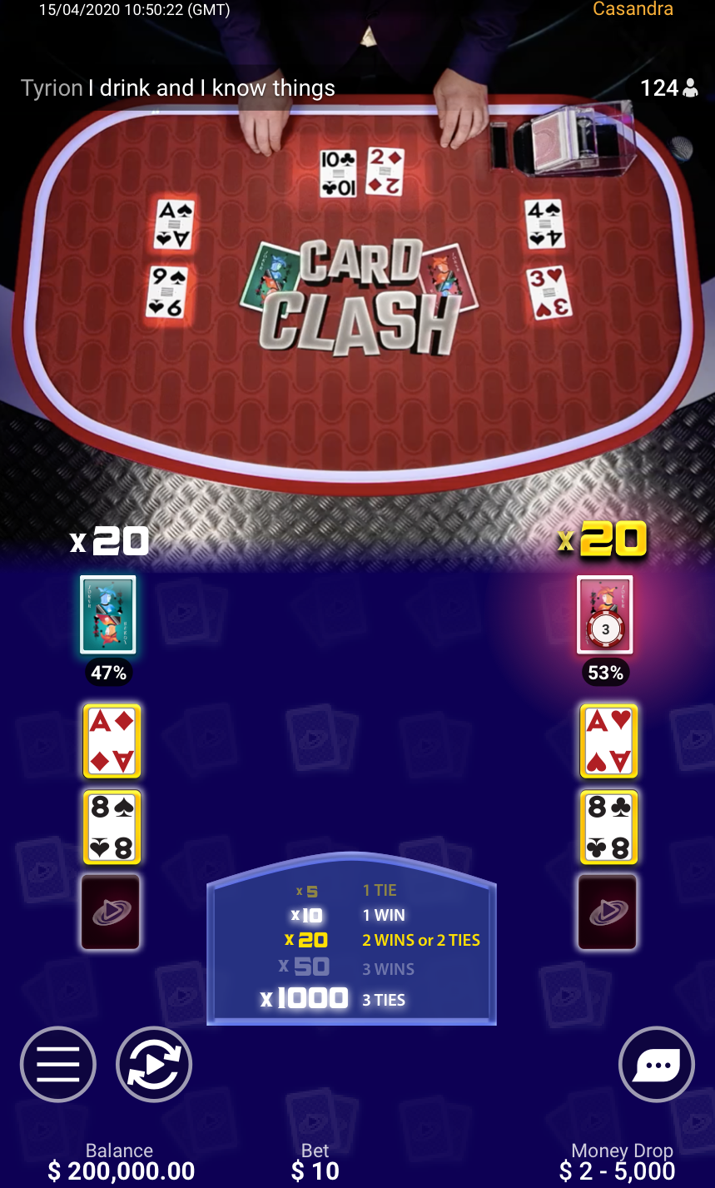

Side Bet for the Watchers
Anyone who:
- joins the game while a Drop Round is still ongoing,
- did not place the bet on the winning Multiplier Bet,
- or dropped all their Money during any Drop Round,
becomes a Watcher. This makes them eligible to place the Winning Zones side bet.
They can select any chip from the chip tray and place it on 1 Drop Zone, to guess the winning zone of that Drop Round. Players can repeat this for each Drop Round (if there are still Drop Rounds left), but they can pick only 1 Drop Zone.
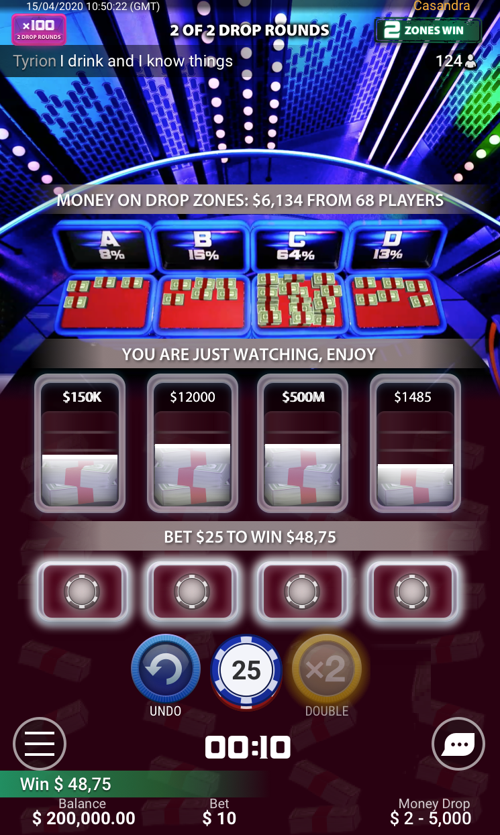

Bet On All Button Added
Players can place bets on all betting positions using the Bet On All button.
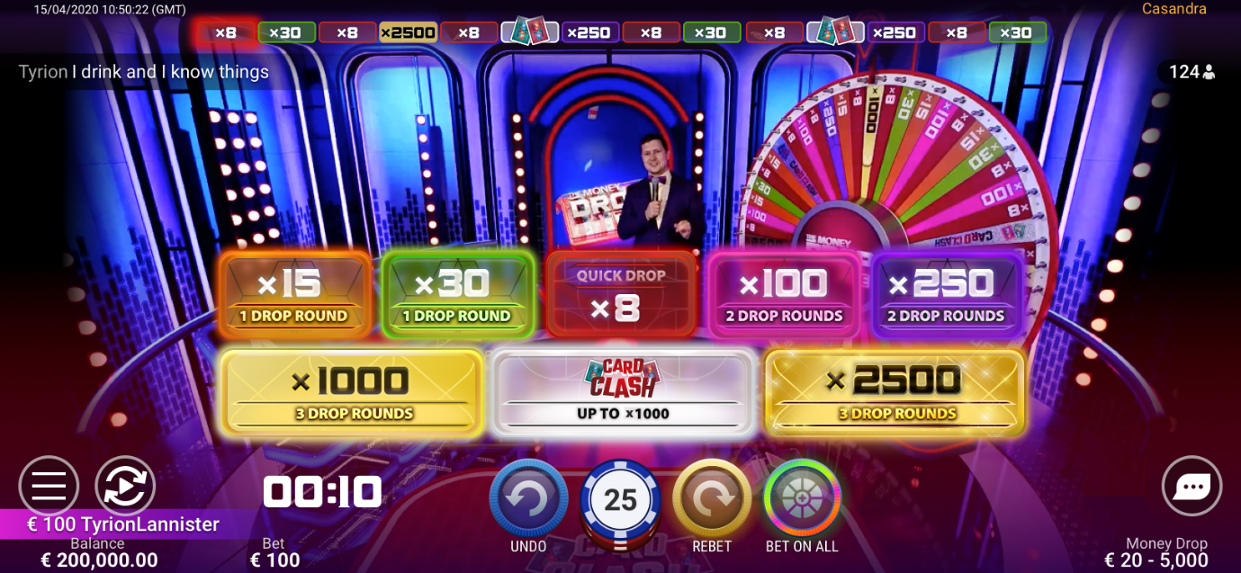

Note about the Autoplay Feature
In this game, Autoplay is not stopped if the player distributes Money during the Drop Rounds, or when then pick their Card Clash side. It is stopped as soon as they adjust their bet(s) on the main betting map.

Document Version
Date | Owner | Description
13.08.2021 | Live Casino | Document created

