Introduction

Dragon Tiger is a very simple and fast-paced game based on luck. It was first introduced in Cambodia and is especially popular among Asian gamblers. Live Dragon Tiger is a comparing card game played between two hands, the "Dragon" and the "Tiger". It represents the symbolic battle between the opposite yet complementary forces of Yin (dark) and Yang (bright). In the Chinese culture, the dragon and the tiger are considered to be evenly matched rivals that are fighting an endless battle. There is even an idiom “Dragon versus Tiger”, which is used to describe equal rivals. In the Live Dragon Tiger, a single card is dealt with the Dragon hand and a single one to the Tiger hand. No additional cards are drawn.
The objective of the Dragon Tiger card game is to guess a hand that has the highest card, the Dragon’s or the Tiger’s, or whether it will be a Tie.
- This game is played with 8 decks of 52 cards
- Aces are the lowest ranked card, and kings are the highest.
- A single card is dealt with the Dragon and a single one to the Tiger
- Players can wager on any number of boxes in the betting area
- In cases of a Tie, the half of wagers on Dragon and Tiger are returned to the player.

Dragon Tiger Bets

The Live Dragon Tiger game offers its players main bets and optional side bets.

Main bets
There are three different kinds of bets in Live Dragon Tiger that can be placed: Each Live Dragon Tiger game has three possible outcomes:

- "TIGER wins" (Tiger has the higher card)
- "DRAGON wins" (Dragon has the higher card)
- "TIE BET wins" (It happens when the Dragon and the Tiger have the same card e.g. the Queen of Hearts and the Queen of Spades)/ ”SUITED TIE BET wins”(it happens when two cards are exactly alike including the suit. e.g. Queen of Hearts and Queen of Hearts).

Additional bets

Beside main the bets, there are the optional side bets on the Big/Small, the Even/Odd, the Red/Black and the card Suit. The Player can wager on any of these regardless of the main bets.
A bet on Big/Small means that player guesses if a card on the Dragon/Player spot will be over or under 7. In cases of any of 8-9-10-j-Q-K cards, the bets on Big win and in the case of any of the Ace-2-3-4-5-6 cards the bets on Small win. In cases of a 7 (seven), all the bets placed on Big/Small lose.
A bet on Even/ Odd means that player guesses if a card on the Dragon/Tiger spot will be even or odd. In case of any of 2-4-6-8-10-Q cards, the bets on Even win. In case of any of Ace-3-5-9-J-K cards, the bets on Odd win. In cases of a 7 (seven), all the bets placed on Even/Odd lose.
A bet on Red/Black means that player guesses if a card on the Dragon/Tiger spot will be red or black. In cases of a 7 (seven), all the bets placed on Red/Black lose.
Players can wager also on correctly guessing if the card Suit on the Dragon/Tiger spot will be Spades, Hearts, Clubs or Diamonds. In cases of a 7 (seven), all the bets placed on Suit lose.

Dragon Tiger Payout

The Live Dragon Tiger pay table is shown below:

- Dragon – pays 1 to 1
- Tiger – pays 1 to 1
- Tie – pays 11 to 1. In case of a Tie, the half of the wager on Dragon and Tiger is
returned to the Player
- Suited Tie – pays 50 to 1. In case of a Suited Tie, the half of the wager on Dragon and Tiger is
returned to the Player
- Big/Small – pays 1 to 1
- Even/Odd – pays 1 to 1
- Suit – pays 3 to 1

General Rules

- All bets at Dragon Tiger shall be made by placing gaming chips on the appropriate areas on the Dragon Tiger table. Wagers can be made during the betting time until the dealer announces "No more bets". Any bets received by our server after this time will be void (win or lose) and the stake(s) will be returned to the player.
- Each player shall be responsible for the correct positioning of his wager or wagers on the Dragon Tiger table.
- Minimum and maximum wagers permitted are shown on the screen of the game in the “TABLE LIMITS” window.
- A bet may be rejected by the system before the betting time is over in case of a slow Internet connection or not meeting the minimum or maximum requirements.
- In case some cards during the game cannot be scanned correctly there can be two solutions. Either the game must be canceled, or the cards will be rescanned. If the game is cancelled, all the players’ bets will be refunded automatically.
- In case the game was over with a wrong result, all players’ wagers will be refunded for the current hand.
- In case more than three cards fell on the floor, the Card change procedure must be done.
- In case two cards come out of the shoe, and one card is not needed for the game, this card shall be “burned” in the discard.
- When the Cutting card appears during play, the Cutting card will be removed and the hand completed. The Dealer will announce “The last Hand of the Shoe”. At the completion of this hand, no more cards should be dealt until the reshuffle occurs.
- In case of any irregularities noticed, please provide a Round Number of the game in question to the Live Chat.

Placing Bets

After selecting a Live Dragon Tiger table from the Lobby, the players may place their bet.
- To place a bet, please select an amount by clicking on a bunch of chips from the Chip Tray on the table and click on the “DRAGON”, “TIGER”, “TIE” or “SUITED TIE” boxes. You can place bets also on DRAGON BIG/SMALL or TIGER BIG/SMALL boxes; on DRAGON ODD/EVEN or TIGER ODD/EVEN boxes; on DRAGON RED/BLACK or TIGER RED/BLACK boxes; on DRAGON/TIGER SUIT (ª,§,©,¨). Your total will be displayed in the "Current Bet" window.
- Player’s bets are placed, removed, changed only during the betting time (15 sec.). Once the betting time is over the Dealer announces “No more bets” and no bets can be placed since.
- Two faced up cards are then dealt: the first card is the Dragon’s hand and the second is the Tiger’s hand.
- Once the Dealer has dealt a card each to the Dragon and Tiger hands and announced the winner, i.e. the game is finished. The Dealer then must collect all the cards on the table and open bets for the next game.
- In the next hand, you can “RE-BET” (place exactly the same bet as in the previous game), “DOUBLE”(place your next bet doubled in respect to the last game bet) or place any other amount by choosing different chips and clicking once or more time on the arrow.
- By clicking the “UNDO” button repeatedly, you will remove bets one by one in the reverse order they were placed. This can only happen during the betting time. See Fig 7.
- All bets on the table can be deleted by pressing the “CLEAR” button. Once bets are closed, it makes impossible to change or cancel your bets.

Outcome of the Game

Each Live Dragon Tiger game has three possible outcomes: "TIGER wins" (Tiger has the higher card), "DRAGON wins" and "TIE BET wins" (It happens when the Dragon and the Tiger have the same card).
When the winning side is announced, an animation related to that side is shown on the screen.

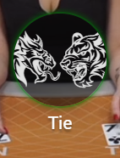​
Game result is Tie

The names of winners come up at the end of each game round.

Shoe Statistics

Live Dragon Tiger current shoe statistics displayed on the screen includes 1) the number of Dragon wins, Tiger wins and Ties so far and 2) the number of completed rounds so far.

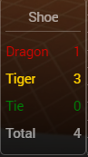​
Current shoe statistics

Dragon Tiger Roadmaps

The Dragon Tiger trends, like Baccarat trends, are recorded on “Roads”, which are pictorial representations of the results and trends of the shoe so far. The roads help players quickly assess the history of the game, identify trends and attempt to predict future results.
The new Round of Dragon Tiger Roadmaps begins when the cards are shuffled and placed in the shoe.
There are five standard roads:
- The Big Road
- Big Eye Boy
- The Small Road
- The Cockroach Pig
- The Bead Plate

The Big Road

The table below represents the game results history recorded on the Big Road roadmap.

​
The Big Road scheme

At first, Dragon Tiger results were just recorded on the “Big Road”. This is the main road and it is the road that all other roads are derived from. The Big Road is quite simple. It is a grid, eight rows deep by many columns wide. When recording the big road, the hollow red circle represents a Dragon win, and a hollow yellow circle represents a Tiger win.
When the shoe begins, the first result (Dragon or Tiger, ignore ties for now) is written in the top left corner of the Big Road. If the second result is the same side as the first, it goes under the first, and as long as the winning side (Dragon or Tiger) remains the same, circles of the same color continue down vertically.
When the “other side” comes up, a new column is started, and the process continues through the entire shoe in this fashion. As a result, the Big Road becomes a series of columns of alternating blue and red hollow circles, with a minimum height of one circle, and no maximum height.
On the Big Road, Ties are not displayed as a separate circle, but simply as a green line across the most recent circle drawn. Multiple ties are shown with a small number next to the green line with that number representing the number of ties.

Ping Pong

Ping-pong is an expression, which describes having a run of alternating Dragons and Tigers. Some players refer to a run of two Dragon alternating with two Tigers as “double ping-pong”.

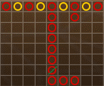​
Ping Pong from columns 1 to 4 and the long “Dragon tail” of 10 Dragons in column 5

Follow the Dragon

If there are more than eight Dragons or Tigers in a row, and the display runs out of room vertically, it is the type of situation the Dragon Tiger players love! The streak simply turns right when it hits the bottom of the grid and continues along the bottom row. Once the streak has turned right, it creates a pattern known as “The Dragon Tail”. This pattern can appear both in case of consecutive Dragon results and in case of consecutive Tiger results. Most Dragon Tiger players agree that if a “dragon tail” appears, you should bet on it, hence the catchphrase, "follow the dragon". Of course, the longer any “dragon tail” the better.

Double Dragon

If a streak happens to bump into a “dragon tail” along the bottom of the big road, it immediately turns right (no matter which row it is in), and creates a new “dragon tail”. Some players refer to this situation as a “Double Dragon”.

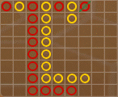​
A Double Dragon roadmap case

The Derived Roads

In 1970 the “Big Eye Boy”, the “Small Road” and the “Cockroach Pig” were invented in Macau. Collectively, these three roads are called the “derived roads”. Some people also refer to them as “predictive roads”.
There are some fundamental differences between the three derived roads and the easy-to-understand big road and bead plate. Here are some important points to understand about the three derived roads:
- They are not a direct representation of the results of the shoe so far.
- They all are derived from the big road and describe the patterns in the Big Road. Each of Big Eye Boy, the Small Road and the Cockroach Pig describe slightly different kinds of patterns. Derived roads do not tell you exactly what happened, they tell you whether there were patterns in what happened.
- The derived roads are made up of yellow and red symbols: hollow circles for the Big Eye Boy, solid circles for the Small Road, and slashes for the Cockroach Road.

IMPORTANT | The red and yellow symbols that make up the derived roads do not correspond to Dragon or Tiger. “Yellow” generally means there is a pattern, and “red” generally means that the shoe is “choppy”, with no pattern.

Due to the operation of the color rules, the derived roads do not start at the beginning of the shoe. They start on the completion of these hands:
- For Big Eye Boy: The hand after the first hand in the second column of the Big Road.
- For the Small Road: The hand after the first hand in the third column of the Big Road.
- For the Cockroach Pig: The hand after the first hand in the fourth column of the Big Road.
Once a derived road starts, an additional yellow or red symbol will be added to that derived road after every hand.

Big Eye Boy

The resulting Big Eye Boy looks as follows:

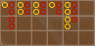​
The Big Eye Boy roadmap

The starting point corresponds to cell B2 on the Big Road scorecard, which is the second result (hand) after the first change in the game. If B2 is empty, the starting point is C1.
For example, the first entry shows cell A1 on the Big Eye Boy table, see Fig 14. This corresponds to the same hand represented in cell C1 of the Big Road table. Since cell C1 is the beginning of a new column, we check if the previous two columns are equal in length. They are, so we color the Big Eye Boy yellow for cell A1. In a contrary case, it would be red.
Next entry to see is C2 on the Big Road. On the Big Eye Boy, it corresponds to B1 red because B1 and B2 don't match.
As column C is finished, we should pass to D1.
The table below will explain all next entries in the Big Eye Boy road.

BIG EYE BOY CELL | BIG ROAD CELL | COLOR | REASON
A1a | C1 | Yellow | Columns A and B equal in length
A1b | C2 | Red | B1 and B2 don't match
A1c | D1 | Red | Columns B and C unequal in length
A2d | E1 | Red | Columns C and D unequal in length
A2e | E2 | Red | D1 and D2 don't match

Small Road

The next table is the “Small Road”. The Small Road works exactly like the Big Eye Boy, except it skips the column to the left of the current column in the Big Road. To have enough information to go on, the Small Road must wait until the entry after the first entry in the fourth column of the Big Road. The resulting Small Road looks as follows:

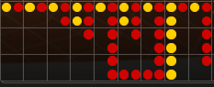​
The Small Road

The starting point for the Small Road corresponds to cell C2 on the Big Road scorecard, which is the second result (hand) after the second change in the game. If C2 is empty, the starting point is D1.

SMALL ROAD | BIG ROAD CELL | Color | REASON
A1a | C2 | Red | B1 and B2 don't match
A1b | D1 | Red | Column A and C are different
A1c | E1 | Yellow | Columns B and D equal in length
A1d | E2 | Yellow | Cells C1 and C2 match
B1a | E3 | Red | Cells C2 and C3 don't match

Cockroach Pig

The starting point corresponds to cell E1 on the Big Road scorecard, which is the second result (hand) after the third change in the game.

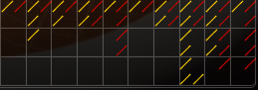​
The Cockroach Pig road

The next table is "Cockroach Road." The Cockroach works exactly like the Small Road, except it skips two columns to the left of the current column in the Big Road. To have enough information to go on, the Cockroach Road must wait until the entry in the fifth column of the Big Road.

COCKROACH PIG | BIG ROAD CELL | Color | REASON
A1a | E1 | Yellow | Columns A and D equal in length
A1b | E2 | Red | Cells B1 and B2 do not match
B1a | E3 | Yellow | Cells B2 and B3 match

The Bead Plate

The Bead Plate is the last road in our statistics window. It is an exact electronic representation of every hand. Red means Dragon, blue means Tiger and green means tie:

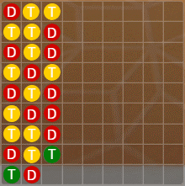​
The Bead Plate

The first symbol appears in the top left corner of the grid, the road fills down vertically through all nine cells of the column, before moving to the second column, and those nine cells are filled in, and so on. There is no moving to a new column until the previous column is filled, irrespective of the result of each hand.
Note that the bead plate shows Ties as a separate symbol occupying a cell in the grid.

Live Dragon Tiger strategies

Live Dragon Tiger is a very simple game based on luck. Still, the players may use a strategy to predict the future outcome. Here are some common strategies the players for the players to use:
- Sticking to the main bets. Some players find that the betting on Dragon or Tiger is statistically more “safe” as the house edge (casino commission) is smaller, so the percentage of return to player is higher compared to other bets. Take note that the chances of a “Dragon Win” or “Tiger Win” result are higher compared to that of a “Tie Win” result. In addition, in case of a tie, half the wager on Dragon/Tiger hand is returned to Player.
- Playing the Suit bet. Players may wager on the Suit bet by guessing the suit of next card on the Dragon hand or the Tiger hand. This is achieved by keeping track of the different suits coming out of the dealing shoe.
e.g. If the Spades, Clubs, and Diamonds appeared more often during previous game rounds, then the chances of Heart suit appearing during next game rounds are higher.
- Using roadmaps. The streak bettors pay attention to different patterns on roadmaps to understand the current shoe trend. When there are several wins in a row by a hands, the streak bettors will most likely bet on that hand until the trend changes.

Screen Elements

The game interface includes the following screen elements.

​ The Live Casino Lobby button is available at any time for any of Live Casino games. It allows you easily to change table or select any other live game. If you choose a table on the screen and click on Play, that table is opened and replaces your current one.

​
The table name shows you the table currently you are playing on and the language sign indicating the national flag.

​
The Live Chat dialog box allows you to chat with the Dealer. Click More/Less to expand/collapse the Chat Room dialog box.
- You must be signed in beforehand to be able to use the Chat Room.
- Please respect the Live Chat rules. Even one violation may lead to a deactivation of your chat privileges.
You can hide other players' chats or the Chat dialog box completely by selecting the desired feature in the Settings box. This can be found by clicking the Settings button - ​ ​ .

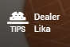​
The Dealer name shows you the name of the Dealer operating at your table.
To give a tip to the Dealer, please click on the Tips icon, select the tip value and click on the Send button.

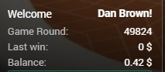​
The User Info area at the bottom left corner of the playing table contains the main info about your account. If your nickname and balance are shown, it means that you are logged in and may enjoy the game.
The Game Round row shows the number of the current game round. This number must be provided to Customer Support in case of any questions you may have during play.
Current Bets displays your total amount of bets on the table in the current game round. If no bets have been placed during the current game round, the Last win is shown in place of Current Bets.
Last Win shows the amount of your win in the previous game round.
Balance shows your available funds. To participate in the game, your balance must be sufficient to cover your bets. This number increases and decreases depending on the result of your action.

​
The Cashier button opens a dialog where you can transfer from, deposit or withdraw money from your account. Your account history is also available in this section.
The Cashier button is optional.

​
If you are not logged into the casino, a Sign In button appears in place of the Cashier button. When you click on Sign In, a dialog where you can enter your login details appears. If you do not have an account in our casino yet, you may create the one by clicking on the Create an Account link in the same dialog box.

​
Click the chip you wish to bet from the Chip Tray and click over the betting area on the table. The selected chip is raised. You may scroll left/right to choose other available chips. There are 11 different chip values in total. You may operate only the chip amounts available within your current balance. The chips of a higher value are not available.

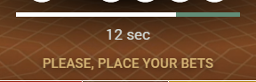​
The Progress Bar shows information messages about the game and your bets status. After the betting time has finished, you will receive the message “You bets have been accepted” above the progress bar indicating if your bets have been accepted, or “Bets have not been accepted by the server” if they have not.

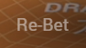​
By clicking on the Re-Bet button, you can place the same bet as in the previous Initial betting round. This button will not be active if no other bets were placed before. After clicking the Re-bet button, it will change to become a Double button. The Re-Bet button is available only when the Dealer shuffles the cards during the Initial betting round.

​
The Double button allows you to double your bet. The Double button is available only during the betting time.

​
By repeatedly clicking the Undo button, you can remove the bets one by one in the reverse order that they were placed. This will only work during the betting time. Once the bets are closed, you cannot change or cancel your bets.

​
Click the Clear button to clear the table of all bets. This button is active if some bets have been placed and can be used only during the betting time.

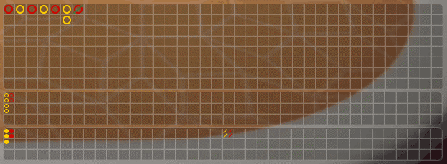​ 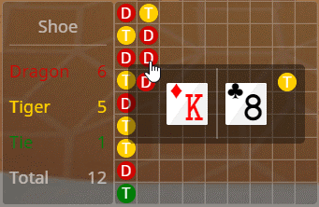​

Dragon Tiger roadmaps are a graphical representation of the games’ past outcomes. The roads help you quickly assess the history of the game, identify trends and attempt to predict future results.
The new Dragon Tiger Round begins when the cards are shuffled and placed in the shoe.
There are five standard roads:
- The Big Road
- Big Eye Boy
- The Small Road
- The Cockroach Pig
- The Bead Plate
To see which cards were dealt with the Dragon and Tiger hands during previous game rounds, the player can hover the cursor over one of the win results in the Bead Plate roadmap cells. This is feature may come in handy when betting on the card suit.
The statistics on the current dealing shoe includes the following:
- The number of Dragon Wins so far
- The number of Tiger Wins so far
- The number of Tie Wins so far
- The total number of completed game rounds so far.

Besides, the Live Dragon Tiger play table includes:
- 4 main boxes (betting positions) – Dragon, Tiger, Tie, and Suited Tie
- 10 boxes related to side bets on Dragon’s hand – Spades, Hearts, Clubs, Diamonds, Even, Odd, Big, Small, Red, and Black.
- 10 boxes related to side bets on Tiger’s hand – Spades, Hearts, Clubs, Diamonds, Even, Odd, Big, Small, Red, and Black.

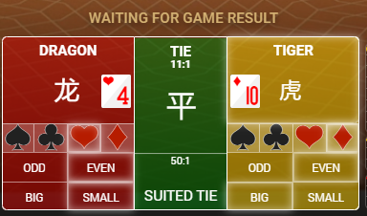​
The Player can place any number of side bets. When the banker starts to scan cards, the card should appear on Dragon`s and Tiger`s boxes. At the end of every game round, the winning boxes are shown highlighted and an animation related to the winning side comes up.
If the player had played in the previous round on some boxes, in the next round on those boxes the
“Re-bet/Double”, “Clear” would appear.
If the “Double” option results in exceeding table limit this option becomes no more active.

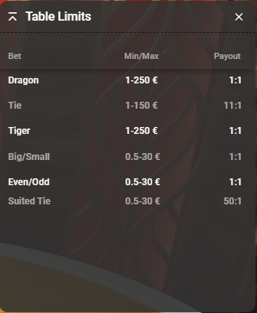​
The Table Limits Board contains a detailed explanation of table limits and odds. In case your bet exceeds any of the indicated limits, a warning message comes up.

​
When clicking on the Table Limits button, a breakdown of min and max stake limits is shown in the Table Limits Board (above).

​
The History button launches a window from the website showing the live Dragon Tiger games you have played and the results of those games. The most recent round appears at the top of the list.
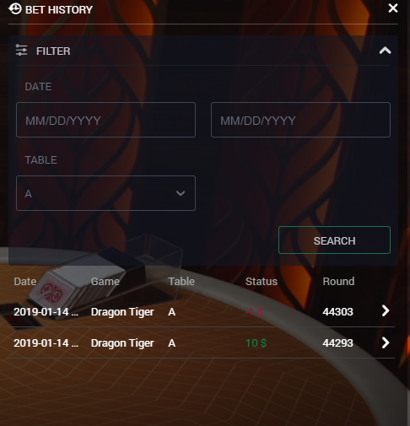​

​
The Sound button turns on/off all sounds and voices during the game. When you change the table, the sound is automatically unmuted.

​
The Game Info button opens a pop-up window with game rules and with this Help info.

​
The Settings button launches a menu with user-controlled settings that include:
- Video Quality (VIP and High);
- Sound Effects (sound effects on/off, background sounds on/off, the pre-recorded voice on/off);
Chat Room (Chat functionality on/off, Other players chat on/off)

​
Click the Full-Screen button to run the game in full-screen mode.

​
To exit Full-Screen mode, you can click the Exit Full-Screen button or press ESC on your keyboard.

​
The results are shown at the end of each game round. The results message comes up together with an animation related to the current winning side for (e.g. Tiger).

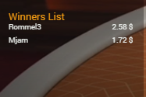​
At the end of each game round, a Winners List comes up.

​
Multi-Game View, located on the right edge of the screen, is a new option for those who like a lot of action! It enables you to play one, two or four different games simultaneously. In the Menu, you can choose any game that is available in Multi-Game View from different sections that your casino offers.

Dragon Tiger Terms
The following list features some of the most common (and most important) Dragon Tiger terms that you will want to know before playing.

Main bet | “Main bet” means a primary bet on a particular playing table. Players can bet on the Dragon, the Tiger or the Tie on the Live Dragon Tiger table.
Side Bet | “Side bet” means a special bet that is placed regardless of the main bets. Players can place side bets on Suited tie
Dragon/Tiger | “Dragon/Tiger” means a spot on the playing table where cards are dealt.
Shoe | “Shoe” means a device from which cards are dealt.
Suited Tie | “Suited Tie” means a wager, which wins if the Dragon hand and the Tiger hand cards match exactly including the suit.
Tie | “Tie” means one of the main wager, which wins if both the Dragon’s and the Tiger's hands have the same cards that exactly match except for the suit and color.
Dragon Tiger Road Maps | “Dragon Tiger Road Maps” are pictorial representations of the results and trends of the shoe, which help players quickly, assess the history of the game, identify trends and attempt to predict future results.
Big/Small | A “Big/Small” means a side bet that a particular card is over or under 7. In case of any of Ace-2-3-4-5-6 cards, the bets on “Dragon Small”/”Tiger Small” win. In case of any of 8-9-10-J-Q-K cards, the bets on “Dragon Big”/”Tiger Big” win. In case of a 7, all bets on Big/Small lose.
Even/Odd | An “Even/Odd” means a side bet that a particular card is even or odd. In case of any of 2-4-6-8-10-Q cards, the bets on “Dragon Even”/”Tiger Even” win. In case of any of Ace-3-5-9-J-K cards, the bets on “Dragon Odd”/”Tiger Odd” win. In case of a 7, all bets on Even/Odd lose.
Red/Black | A “Red/Black” means a side bet that a particular card is red or black. In case of any of Hearts or Diamonds suits, the bets on “Dragon Red”/”Tiger Red” win. In case of any of Clubs or Spades suits, the bets on “Dragon Black”/”Tiger Black” win. In case of a 7, all bets on Red/Black lose.
Suit | A “Suit” bet is a wager on any of the card suits (Spades, Clubs, Hearts, and Diamonds). The player guesses the card suit that will next appear on the Dragon hand or the Tiger hand. In cases of a 7, all bets on suit lose.

Return to Player

The theoretical percentage return to the player in the Live Dragon Player game is as follows:
Dragon- 96.26%
Tiger – 96.27%
Tie - 89.64%
Suited Tie - 86.03%
Big/Small – 92.31%
Even/Odd - 92.31%
Red/Black – 92.31%
Suit - 92.31%
Over/ Under 7-92.31%

Note: Win amounts are always rounded down to 2 numbers after the dot and lose amounts are rounded up to 2 numbers after the dot in bet history and transactions history sections. The whole numbers (win/lose) without rounding which are added to or extracted from the players' balances are depicted in the round history section.

