Game Overview:

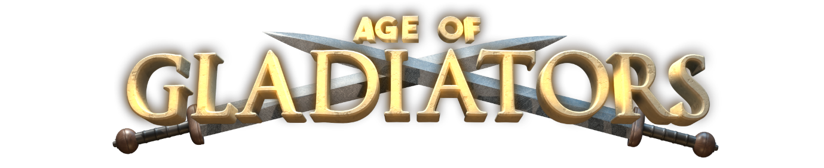

Age of Gladiators – Video Slot

Tag Line:
Emerge from the shadow of the Colosseum into the sun scorched arena and prepare to do battle with whatever comes through those gates! Hack and slash your way to victory in this cinematic epic!

Theme:
A video slot themed around the gladiatorial battles of ancient Rome. With gameplay that is both as brutal and as rewarding as the historic battles themselves.

Outline:
A tried and tested favourite video slot recipe.

Notable Features
- Win up to 61,400 Coins!
- Win up to 8 Free Spins at x2
- Wild x2 Multiplier
- 9 Coin, 5 Line
- Gamble Game
Symbol Profiles:

Sym# | Sym Name | Sym Image | Function
 | Cash Vegas Logo (x2 Wild) |  | The Wild symbol substitutes any symbol except the Scatter symbols. Any win with the Wild symbol DOUBLES your win.
 | Star (Free Spins) |  | 3 or more Free Spins symbols anywhere on the reels activate Free Spins.  Free Spins can be activated again during Free Spins.
 | Multipot Wheel (Feature) |  | 3 or more Feature symbols anywhere on the reels launches the feature game.  Does not appear in Free Spins.
 | Red 7 (Scatter)
 | Yellow 7s
 | BAR 3
 | BAR 2
 | BAR 1
 | Cherries
 | Lemon
 | Bell

General Rules:

All wins pay left to right except Scatter symbols which pay any. All payline wins are multiplied by credits wagered per line. Scatter wins are multiplied by the TOTAL credits wagered. Scatters are paid in addition to payline wins. Only highest win (from both directions) is paid on each active payline.

