Game Overview:

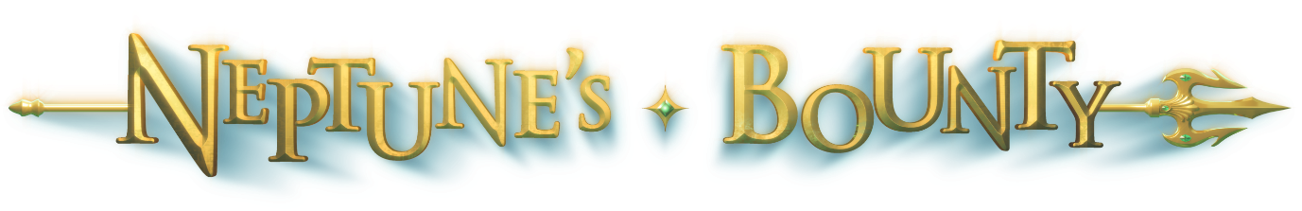
Neptune’s Bounty – Video Slot

Tag Line:
Neptune, ruler of all the oceans, beckons you forth to his realm. Immerse yourself amongst all the treasures of his kingdom. Will you be granted entry to his Throne Room, to witness even greater riches… or will you steel yourself and venture into the Kraken’s Cavern and the wealth of secrets it holds?

Theme:
Underwater Mythological adventure, with 3D graphics and animation.

Outline:
A rich, colourful, fun video slot with a Double High Wild, Free Spins and Choice of 2 Feature Games.

Notable Features:
- Win up to 14,240 Coins!
- Win up to 22 Free Spins
- Double High Wilds
- Choice of 2 Feature Games
- 5 Coin, 15 Line

Symbol Profiles:

Sym# | Sym Name | Sym Image | Function
00 | Neptune | 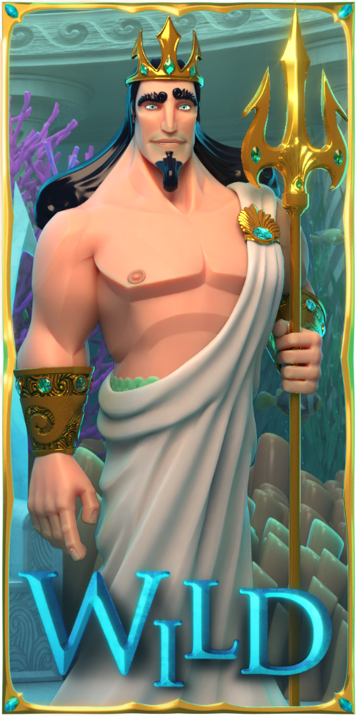 | The Wild symbol substitutes any symbol except the Scatter symbols.  Neptune Double High Wilds appear on All Reels
01 | Free Spins |  | 3 or more Free Spins symbols anywhere on the reels activate Free Spins.  Free Spins can be activated again during Free Spins
02 | Versus | 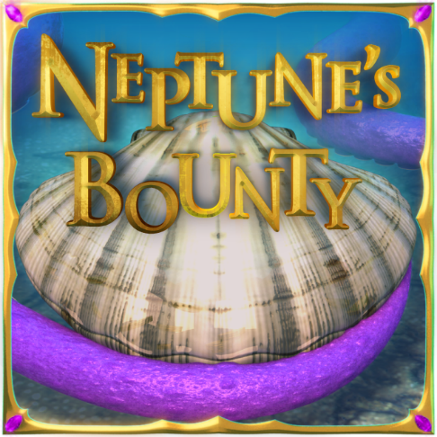 | 3 or more Feature symbols anywhere on the reels activate a choice of 2 Feature Games.  Prizes are proportional to the total bet amount of the game that triggered the Feature Game.  The Feature Games cannot be activated during Free Spins.
03 | Logo | 
04 | Gold | 
05 | Vault | 
06 | Guard Tower | 
07 | Car | 
08 | Plans | 
10 | A | 
11 | K | 
 | Q | 
 | J | 

General Rules:
All wins pay left to right except Scatter symbols which pay any. All payline wins are multiplied by credits wagered per line. Scatter wins are multiplied by the TOTAL credits wagered. Scatters are paid in addition to payline wins. Only the highest win is paid on each active payline.

